CHAPTER 1
INTRODUCTION

1.1 Data Structure
A data structure is a systematic way of organizing, managing, and storing data so that it can be accessed and modified efficiently. It defines the relationship between the data and the operations that can be performed on that data. Data structures are the foundation of efficient programming and algorithm design.

1.2 Importance of Data Structures
Data structures are crucial for solving complex computational problems and optimizing performance. Efficient data structures lead to faster execution, lower memory usage, and scalable code. They are used in various domains such as artificial intelligence, databases, operating systems, graphics, networking, and more.

1.3 Basic Terminologies
- Data: Raw facts and figures.
- Information: Processed data with meaning.
- Data Type: A classification of data which tells the compiler or interpreter how the programmer intends to use the data (e.g., int, float, char).
- Abstract Data Type (ADT): A model for a data structure that specifies the type of data stored, operations supported, and the types of parameters of the operations.

1.4 Types of Data Structures
Data structures can be broadly classified into the following categories:

1.4.1 Linear Data Structures
- Array: A collection of elements stored at contiguous memory locations.
- Linked List: A linear collection of data elements called nodes, where each node points to the next.
- Stack: A LIFO (Last-In, First-Out) structure.
- Queue: A FIFO (First-In, First-Out) structure.

1.4.2 Non-linear Data Structures
- Tree: A hierarchical data structure with nodes connected by edges.
- Graph: A collection of nodes connected by edges, useful for representing networks.

1.4.3 Hash-based Structures
- Hash Table: A structure that maps keys to values using a hash function for efficient lookups.

1.5 Operations on Data Structures
Common operations include:
- Insertion: Adding a new element.
- Deletion: Removing an existing element.
- Traversal: Visiting elements in a particular order.
- Searching: Finding a specific element.
- Sorting: Arranging elements in a particular order.

1.6 Need for Data Structures in Programming
Without proper data structures, even simple problems can become complex and inefficient. Choosing the right data structure can lead to:
- Reduced complexity
- Easier data management
- Better performance and resource usage

1.7 Applications of Data Structures
Data structures are used in:
- Compilers and interpreters
- Databases and file systems
- Operating systems
- Artificial Intelligence
- Web development and APIs
- Gaming and simulation

CHAPTER 2

METHODOLOGY

2.1 Objective
The primary objective of this project is to design and implement a Railway Ticket Reservation System using the Queue data structure in C programming language. This system simulates a real-time railway reservation process where passengers are handled in an organized and systematic manner.
The project focuses on applying the concept of First Come First Serve (FCFS) using queues, ensuring that passengers who reserve tickets earlier are given priority during ticket issuance.
The specific objectives of this system include:
- To create a user-friendly reservation system that allows passengers to enter their details such as name, age, and gender.
- To implement queue operations (enqueue and dequeue) for managing ticket reservations and issuing tickets.
- To automatically generate unique ticket numbers for each passenger using a ticket counter.
- To ensure data validation and accuracy, such as:
  - Accepting only alphabetic characters for names
  - Accepting only numeric values for age
  - Restricting gender input to Male, Female, or Transgender
- To prevent duplicate reservations by checking existing passenger records.
- To display the current waiting list of passengers in the queue.
- To handle exceptional conditions like:
  - Queue Overflow (when maximum limit is reached)
  - Queue Underflow (when no passengers are available)
- To provide a simple menu-driven interface for easy interaction with the system.
This project helps in understanding how data structures like queues can be used in real-life applications such as railway booking systems, where maintaining order and efficiency is very important.

2.2 Problem Statement
In real-world railway systems, managing passenger reservations efficiently is a critical task. During peak times, handling multiple booking requests manually can lead to errors such as duplicate entries, invalid data input, and improper order of ticket issuance.
The traditional reservation process requires a system that can:
- Maintain the order of booking
- Avoid duplicate reservations
- Ensure valid passenger details
- Handle limited seat availability
To address these challenges, there is a need to develop a simple and efficient Railway Ticket Reservation System that can automate the reservation process and manage passengers systematically.
This project aims to design a system using the Queue data structure in C, where:
- Passengers are added to the system in the order they make reservations (First Come First Serve principle).
- Each passenger is assigned a unique ticket number.
- The system validates user inputs to ensure correctness.
- Duplicate reservations are restricted.
- Tickets are issued in the same order as booking.
- The system can display the current waiting list of passengers.
The system also needs to handle conditions such as:
- Queue Overflow when the maximum number of reservations is reached.
- Queue Underflow when there are no passengers to process.
Thus, this project provides a simplified model of a real-world railway reservation system, demonstrating how data structures can be effectively used to solve practical problems.

2.3 Technology Stack
The Railway Ticket Reservation System is developed using the following technologies:
1. Programming Language
- C Programming Language
  - Used to implement the entire system logic.
  - Provides support for structured programming, functions, and memory management.
2. Data Structure
- Queue (Linear Queue)
  - Used to manage passenger reservations.
  - Follows First Come First Serve (FCFS) principle.
  - Implemented using arrays.
3. Concepts Used
- Structures (struct)
  - To store passenger details like ticket number, name, age, and gender.
- Functions
  - Used for modular programming (enqueue, dequeue, display, validation).
- Input Validation
  - Ensures correct data entry (name, age, gender).
- String Handling
  - Using string.h functions like strcmp().
- Character Handling
  - Using ctype.h functions like isalpha().
4. Development Environment
- Any C compiler such as:
  - GCC Compiler
  - Turbo C
  - Code::Blocks / Dev-C++ / VS Code
5. Operating System
- Works on:
  - Windows
  - Linux
  - macOS

2.4 Project Description
The Railway Ticket Reservation System is a simple console-based application developed using the C programming language. This project is designed to simulate the basic functionality of a real-world railway reservation system by using the Queue data structure.
In this system, passengers can reserve tickets by entering their details such as name, age, and gender. Each reservation is stored in a queue, ensuring that passengers are handled in the order of their booking based on the First Come First Serve (FCFS) principle.
The system automatically generates a unique ticket number for every passenger at the time of reservation. It also includes validation mechanisms to ensure that:
- Names contain only alphabets
- Age is entered correctly as a number
- Gender is restricted to Male, Female, or Transgender
Additionally, the system prevents duplicate reservations by checking if a passenger with the same name and age has already booked a ticket.
The application provides the following core functionalities:
- Ticket Reservation (Enqueue): Adds a passenger to the queue
- Ticket Issuing (Dequeue): Removes the passenger from the queue and issues the ticket
- Display: Shows the current waiting list of passengers
The system also handles exceptional conditions such as:
- Queue Overflow: When the maximum number of passengers is reached
- Queue Underflow: When there are no passengers in the queue

CHAPTER 3

RESULTS AND DISCUSSION

Screenshots

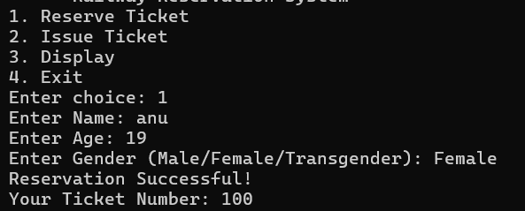

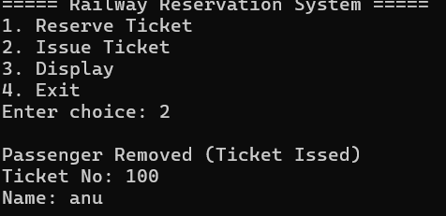

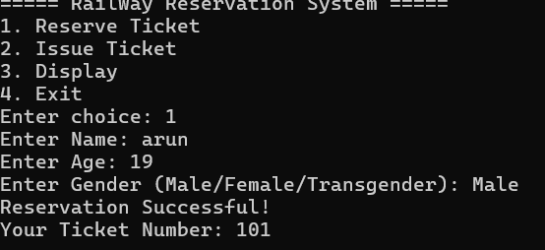

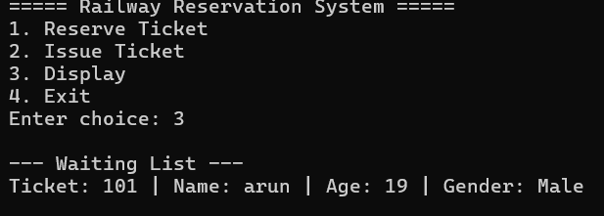

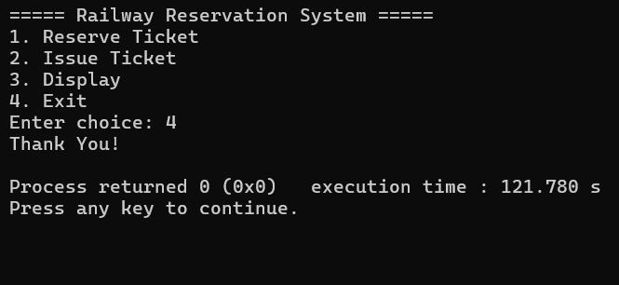

CHAPTER 4

CONCLUSION
The railway ticket reservation system developed in this project successfully demonstrates the use of the queue data structure in solving real-world problems. By following the first come first serve (fcfs) principle, the system ensures that passengers are served in the exact order of their reservation, making the process fair and systematic.
The project effectively handles key functionalities such as ticket reservation, ticket issuing, and displaying the waiting list. It also incorporates important features like input validation, duplicate checking, and automatic ticket number generation, which improve the reliability and accuracy of the system.
Additionally, the system manages exceptional cases like queue overflow and underflow, ensuring stability during execution. The use of structures and modular functions makes the program organized, readable, and easy to maintain.
Overall, this project provides a clear understanding of how fundamental programming concepts and data structures can be applied to develop practical applications. It also serves as a foundation for building more advanced reservation systems in the future.

REFERENCES
- Horowitz, E., Sahni, S., & Anderson-Freed, S. (2008). Fundamentals of Data Structures in C (2nd ed.). Universities Press.
- Weiss, M. A. (2013). Data Structures and Algorithm Analysis in C++ (4th ed.). Pearson Education.
- Tanenbaum, A. S., & Langsam, Y. (1991). Data Structures Using C. Prentice Hall.
- (2nd ed.). Wiley.
- Shaffer, C. A. (2011). Data Structures and Algorithm Analysis. Dover Publications.

